ST. XAVIER’S COLLEGE

**Maitighar,Kathmandu**

**(Affiliated to Tribhuvan University)**



**Computer Graphics**

**Lab Assignment #4**

**Submitted By**

PRANESH DHUNJU SHRESTHA

013BSCIT026

**Submitted To**

Er. Anil K. Sah

Lecturer

Department of Computer Science

St. Xavier’s College

Maitighar, Kathmandu

**Submitted On**

August 18, 2015

**STATEMENT**

DRAW A LINE USING BLA ALGORITHM WHERE USER PROVIDES THE LINE COORDINATES.

**ALGORITHM**  
STEP 1: Input two points (x1, y1) & (x2, y2).  
STEP 2 : Determine the differences dx = x2 - x1 and dy = y2 - y1.  
STEP 3 : Calculate the initial decision parameter P = 2dy - dx.  
STEP 4 : For each xk along the line starting at k = 0,  
    if Pk < 0,  
       a) put a pixel at (xk + 1, yk)  
       b) Pk+1 = Pk + 2dy  
    else  
       a) put a pixel at (xk + 1, yk + 1)  
       b) Pk+1 = Pk + 2dy - 2dx.

STEP 5 : Repeat step 4 for dx time.  
STEP 6 : End

**SOURCE CODE**

//---------------------------------------------------------------------------

#include <vcl\vcl.h>

#pragma hdrstop

#include "bla.h"

//---------------------------------------------------------------------------

#pragma resource "*.dfm"

TForm1 *Form1;

int dx,dy,p,end;

float x1,y1,x2,y2,x,y;

//---------------------------------------------------------------------------

__fastcall TForm1::TForm1(TComponent* Owner)

: TForm(Owner)

{

}

//---------------------------------------------------------------------------

void __fastcall TForm1::Button1Click(TObject *Sender)

{

x1=StrToInt(Edit1->Text);

y1=StrToInt(Edit2->Text);

x2=StrToInt(Edit3->Text);

y2=StrToInt(Edit4->Text);

dx=abs(x2-x1);

dy=abs(y2-y1);

p=2*dy-dx;

if(x1>x2)

{

x=x2;

y=y2;

end=x1;

}

else

{

x=x1;

y=y1;

end=x2;

}

Image1->Canvas->Pixels[x][y]=RGB(100,50,255);

while(x < end)

{

x=x+1;

if(p < 0)

{

p=p+2*dy;

}

else

{

y=y+1;

p=p+2*(dy-dx);

}

Image1->Canvas->Pixels[x][y]=RGB(100,50,255);

}

}

//----------------------------------------------------

**OUTPUT**

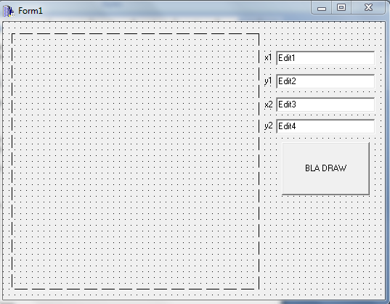

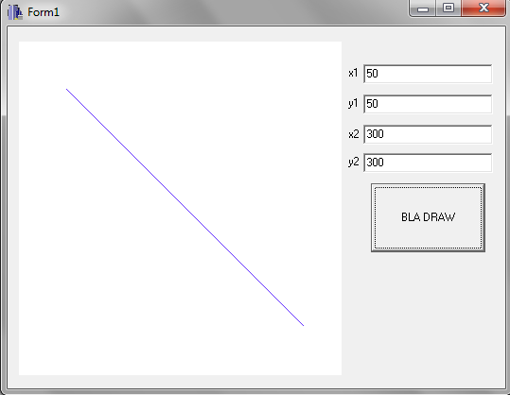

**CONCLUSION**

Thus, using C++ builder BLA algorithm was implemented and result was displayed above.